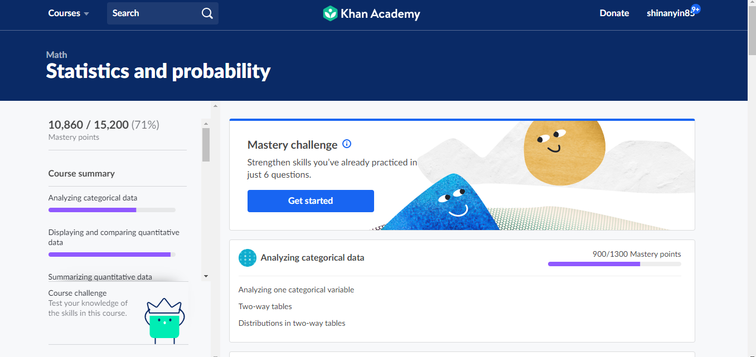

Missing sections:

Counting, permutations, and combinations and sections below Two-sample inference for the difference between groups. I will finish them in this week. Another reason that the scores did not reach 100% because there are sections that I did not reach proficient or I passed out the unit tests.